Identifying Project

The project was to replace the old controllers inside an obsolete 1980’s pick and place machine so it could be used with modern software.

As we were the first team to work on this project we had to make some decisions that would affect future teams. We decided to make a modular system with a set of microcontroller PCB’s all daisy chained together and controlled from a master controller possibly a Personal Computer.

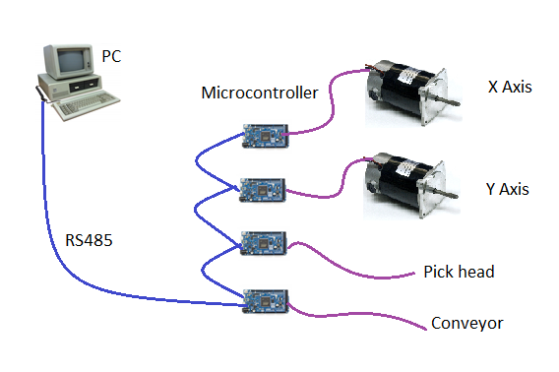We decided to use RS485, an industrial serial bus standard to link the controllers together, only a few of the Arduino range of microcontrollers have CAN so this would be limiting the type of microcontrollers that could be used.

We chose to control the X and Y motor’s, both motors are controlled in the same way.